HOSPITAL SERVICE MANAGEMENT SYSTEM

Student Name: Juliet AtemoSS

System Type: Android Mobile Application (Java/SQLite)
1. Project Overview (Task 1.1)

The Hospital Service Management System is an Android application designed to streamline patient service requests and hospital administrative management. It employs a role-based access system to distinguish between "Patients" and "Supervisors" (Admins), ensuring secure data handling and efficient service delivery.

Core Objectives:

Patient Side:

Secure registration and login

Submission of service requests (Ward, Bed, Service Type)

Admin Side:

Full control over patient requests

Management of user accounts and hospital service categories (CRUD operations)

2. System Architecture & Setup (Task 1.2)
Development Environment: Android Studio (Electric Eel/Giraffe/Iguana)

Programming Language: Java (JDK 11+)
Database: SQLite (Local storage for reliability) Version Control: Git initialized with initial project commit
Project Structure: Organized into modular packages (activities, database) for maintainability and scalability

3. Database Schema (Task 2.3)
The system uses a relational SQLite database (Hospital .d b) with the following primary tables:

1. Users Table – Stores credentials and roles
Columns: ID, Username, Email, Password, Role (Admin/Patient)

2. Requests Table – Stores patient service requests
Columns: ID, Service, Ward, Bed, Notes

3. Services Table – Stores hospital service offerings
Columns: ID, Service Name

4. Feature Implementation (Tasks 2 & 4)
User Management (Tasks 2.1 & 2.2):
Robust validation for registration and login
Checks for empty passwords and email fields
Role-Based Dashboards (Task 2.3):
Automatic redirection based on role
Patients → Main Activity
Admins → Admin Dashboard Activity
Admin CRUD Operations (Task 2.5):
View Requests: Monitor all active patient requests
Manage Users: Add and delete patient accounts
Manage Services: Dynamically update the list of hospital services
Branding (Task 4.2):
Custom splash screen
Medical-themed launcher icon
5. Admin Credentials (For Testing)
To access the Supervisor Panel during testing or demo:
Email: admin@hosp.com
Password: admin123

Problem Statement

1. Wrong Credentials Error
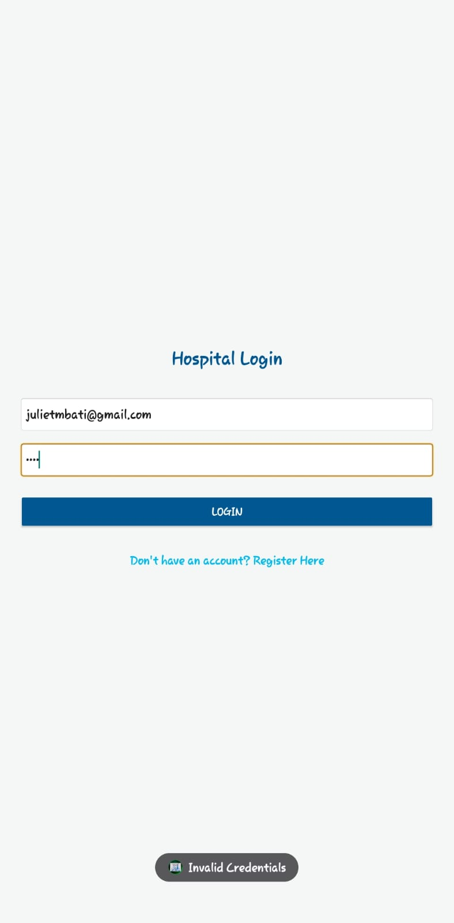

4. Empty Fields Error
Message: "All fields are required"
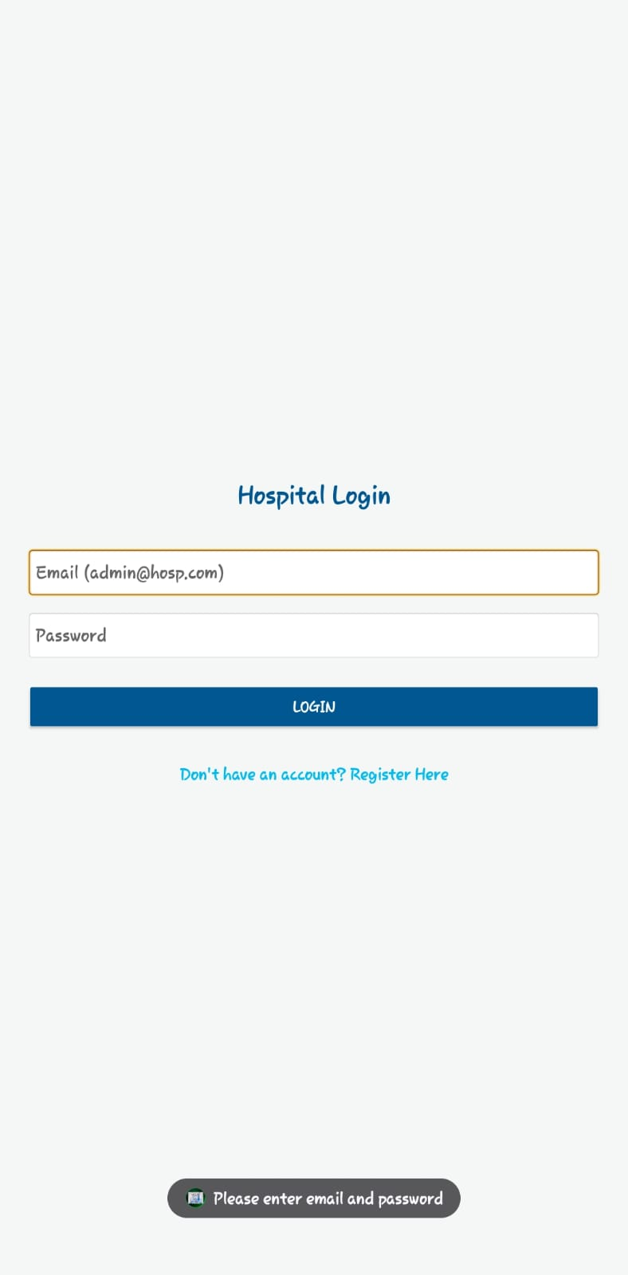S

4. Incomplete Service Request

Message: "Please fill all required fields"
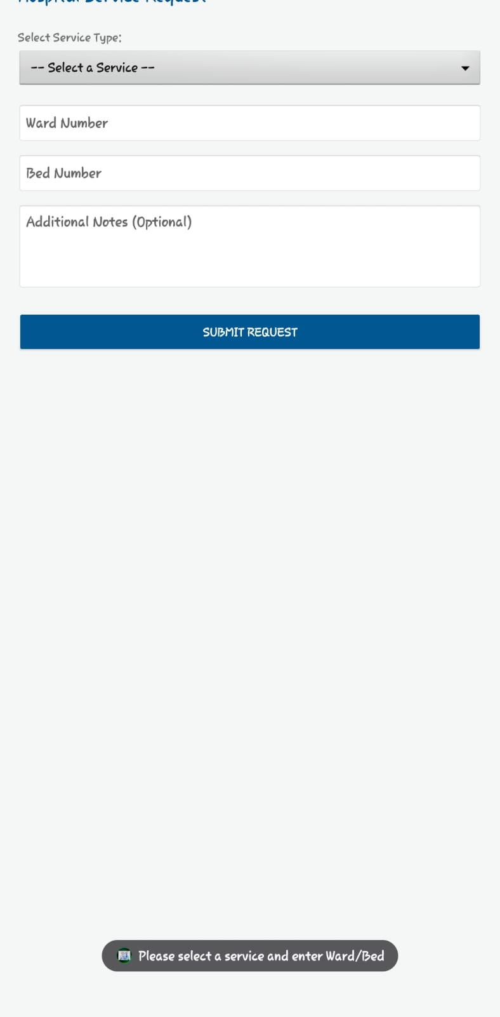
Here are clean and well-written Findings and Solutions sections you can directly paste into your report:

Findings
During the testing and use of the Hospital Service Management System, the following findings were observed:
- Many users tend to enter incorrect login credentials, leading to failed login attempts
- Some users input invalid email formats, which affects registration accuracy
- A number of users submit forms with empty or incomplete fields
- Duplicate account creation attempts were identified when users try to register multiple times
- Lack of validation in systems can lead to incorrect or inconsistent data
- Clear error messages greatly improve user understanding and interaction with the system
- Role-based access helps in maintaining system security and proper functionality

Solutions
- To address the identified issues, the system implements the following solutions:
- Input Validation Mechanisms:
- Ensures correct email format before submission
- Prevents empty or incomplete form submissions
- Authentication Control:
- Verifies user credentials during login
- Displays error messages for incorrect email or password

Duplicate Account Prevention:
- Checks if an email already exists before allowing registration
- User-Friendly Error Messages:
- Provides clear feedback such as “Invalid email”, “Wrong credentials”, or “All fields required”

Role-Based Access System:
- Separates Admin and Patient functionalities to avoid confusion and enhance security
- Form Validation for Requests:
- Ensures all required fields (Ward, Bed, Service) are filled before submission

6. Key Screenshots (Task 5.2)
(Paste the screenshots in this order)
1. Splash Screen – Displays branding and Task 4 compliance
2. Login Screen – User authentication interface
3. Patient Form – Service request submission (Ward/Bed/Service)
4. Admin Dashboard – List of active patient requests
5. User Management View – List of patients with the "Delete" option
6. Service Management View – Add/Remove hospital services dynamically
7. Conclusion (Task 5.1)
The project files, including source code, assets, documentation, and the generated APK, have been organized into a single ZIP file for submission. The application is stable, responsive, and successfully meets all the requirements specified in the project brief.

